Friends of Greenberg
Designer Bag Bingo Night
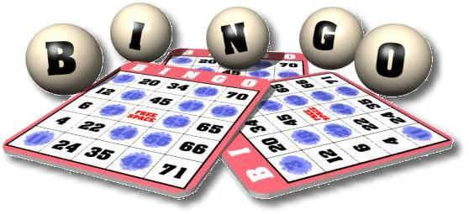
Saturday, May 18th from 7:00 - 11:00 PM
Doors open at 6:45 pm – Bingo starts promptly at 7:30 pm

Location: St. Martha Parish, 11301 Academy Road, Philadelphia, PA 19154
(entrance is through the door on front side of the building as you enter the lot)
Open to Adults Only – Must be 21 or older to play

TICKET PRICES
TICKETS $25.00 in ADVANCE (CASH ONLY) or
$30 at the door if any tickets remain after presale
Only 200 Tickets will be sold

Your ticket price includes:
- 10 games of bingo
- Door prizes
- Light Refreshments*
*You may bring your own food and beverage of choice!

★Extra Bingo Sheets $10 ★ 50-50 Tickets 5 tickets for $10★
★3 Cash Bingo Rounds for $20 ★Raffle Baskets 25 tickets for $20★
All extra for purchase at the event

Email or call Kelly Landherr at Greenberg with questions
krhatfield@philasd.org or 215-400-3080 ext. 4

----------detach and return for presale tickets to Greenberg Main Office-----------

Your Name______________________________________ Phone______________________________
Child’s Name/HR ________________________________ Number of Tickets___________________
Amount Enclosed________________________________
8 or more tickets ordered together = a reserved table (tables seat 8-10)

